Using the Document Upload Wizard
The Document Upload Wizard is available on the Net Partner Student Portal and is designed to lead the student through the necessary steps to upload their documents. The Document Upload Wizard is only available to students to upload documents to the Financial Aid Office.

Steps for Students to Upload Documents
- Log on to TheHub
- Click My Financial Aid
- Log on again with your username and password for TheHub
- The academic year should be set as 2021-22 in the upper right corner

- Click Menu and select My Documents & Messages
- Find document needed from the My Documents List
- Click on Upload it now!
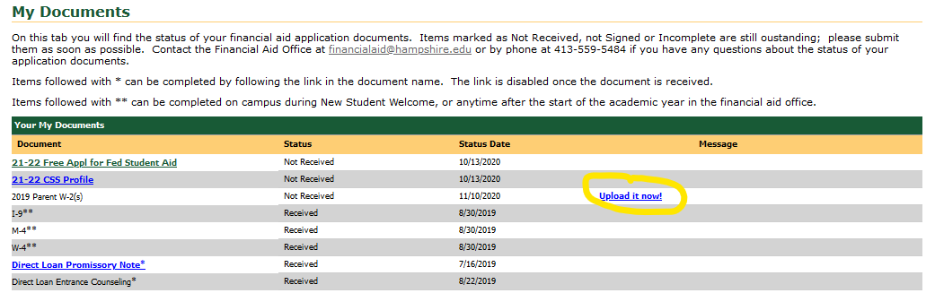

- Click Browse to find your document to upload. Note: document must be a PDF or JPEG file with a file size of 25MB or less.
- Once you find your document click Open, then click Upload. Close window when upload is successful.
- The document you uploaded will now have a status of “Not Reviewed” in the My Documents List.
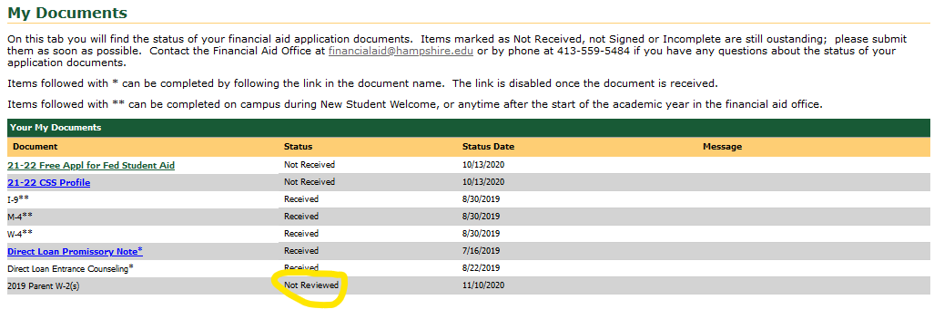
- Repeat as needed for other required documents. Once you are finished you may log out and the Financial Aid Office will review your documents and let you know if additional information is needed. Check Net Partner often for updates.
- Would you like to upload a document but do not see that item listed in your Document list? Email us at financialaid@hampshire.edu and we will add the document to enable the upload process.

