Web Requisitions Training

- Sign into the HUB and click on Enter a Requisition
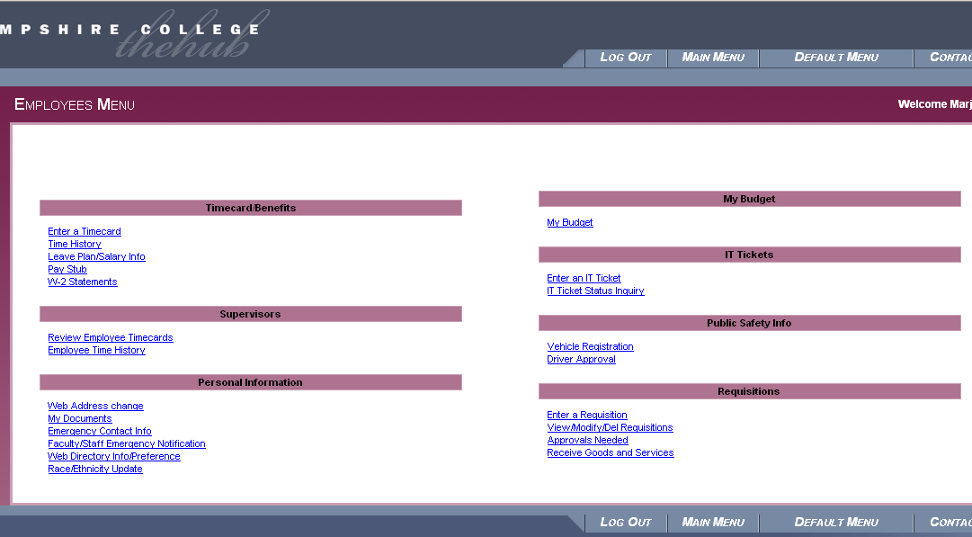

- Enter a vendor name or some part of a vendor name; for example, Atkins will retrieve records for Atkins Country Market as well for as anyone with that string of characters as part of the name. Sometimes Colleague can be fussy, however, so if you are fairly certain that the vendor already exists in the system, try various versions of the name until you succeed.
- Choose the correct vendor and click SUBMIT. The address listed should match the address on the invoice. If not, please contact the vendor for an updated W-9, phone, e-mail and remit to address. Current W-9 forms can be obtained from the IRS website.

  - If the vendor you are paying is not listed, contact the vendor and ask them to submit a W-9 form to the purchasing office and to include phone, email and confirm the remit to address. Email purchase@hampshire.edu to expect a W-9 for that vendor and indicating what address any checks to that vendor should be sent.

- At the top of the Enter a Requisition page, leave Desired Date field blank and confirm all other information. (See below for details.)
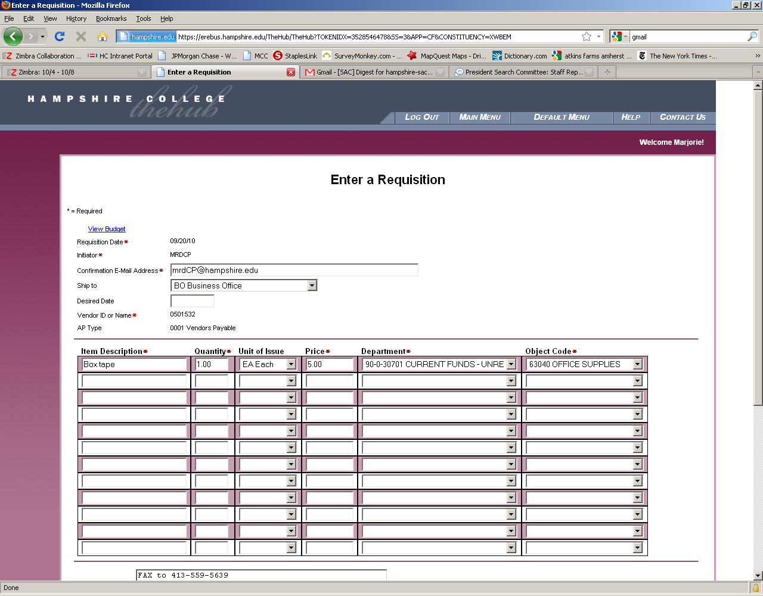
- In the middle of the page, enter
  - an Item Description
    - Item Description field has a limited number of characters and words can be abbreviated
  - a Quantity of 1
  - Unit of Issue should remain Each
  - the total amount from the invoice under Price
  - then select the Departmental account number and Object Code from the drop down list.
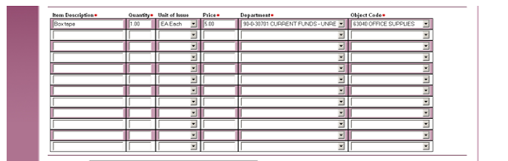
- If the vendor wants a copy of the purchase order (somewhat rare), enter those instructions in the Printed Comments box. For example, if you would like the PO faxed to a vendor, put FAX and include the fax number. If you would like the PO emailed to you, put SEND and your email address in printed comments. Note that this is a somewhat uncommon process; if there are no instructions, then the PO will not be printed. (Most vendors who request a PO are only interested in the PO number and not an actual copy of the purchase order itself.)
The Comments box is optional can be used for your tracking purposes.
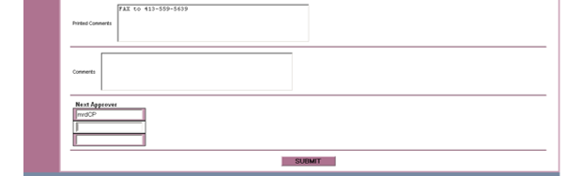
- Enter your own initials and department (mjgPP), NOT the full email address, as Next Approver. If the requisition is over your purchasing limit, enter your supervisor’s initials and department.
  - If the requisition is between $10,000 and $50,000, also enter the Director of Accounting’s initials and department (Jill Ludkiewicz, jtbBO).
  - Alternatively, if the requisition is over $50,000, enter the Sr. Director of Budgets and Planning’s initials and department (John Dineen, jdBO). If you are uncertain whose code to enter, email acctspay@hampshire.edu or call ext. 5491.
  - Warning: If the requisition amount requires an approver and you fail to add the correct person/people, the system will not alert you to the problem. If you have not received a PO number within a few days of submitting the requisition, this is often the reason. See “Modify Requisition”, below, to add the correct approver.
- Click Submit at the bottom of the page.
- If the requisition was created successfully you will be brought to the following page. Review and click OK.
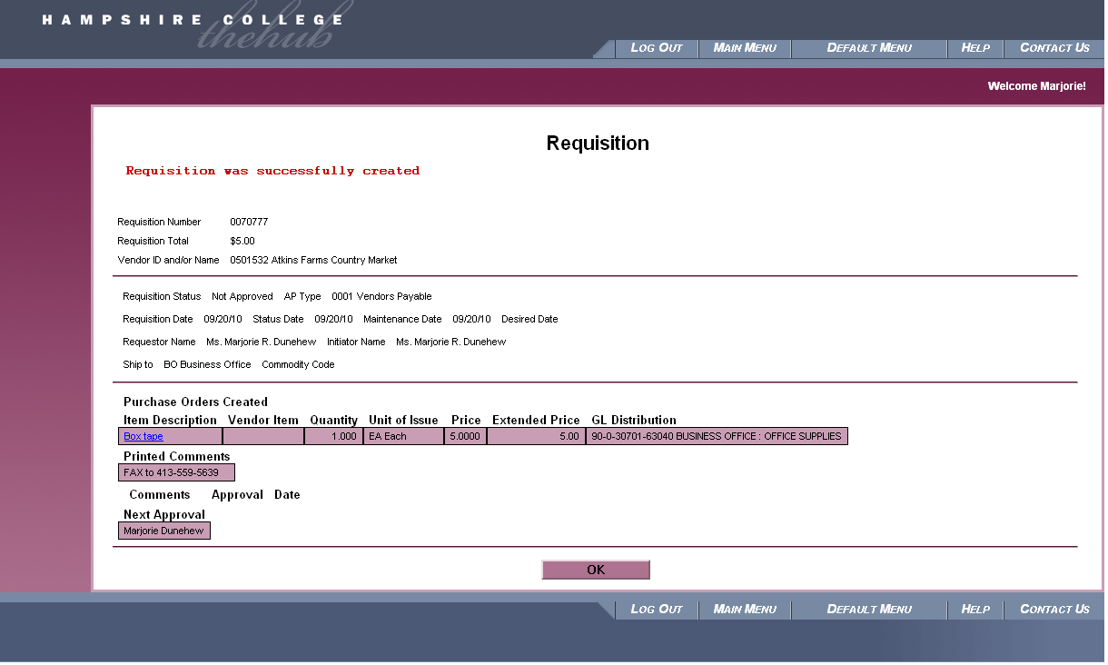
- The next step is to approve the requisitions. Go back to the Hub main menu and click on Approvals Needed.
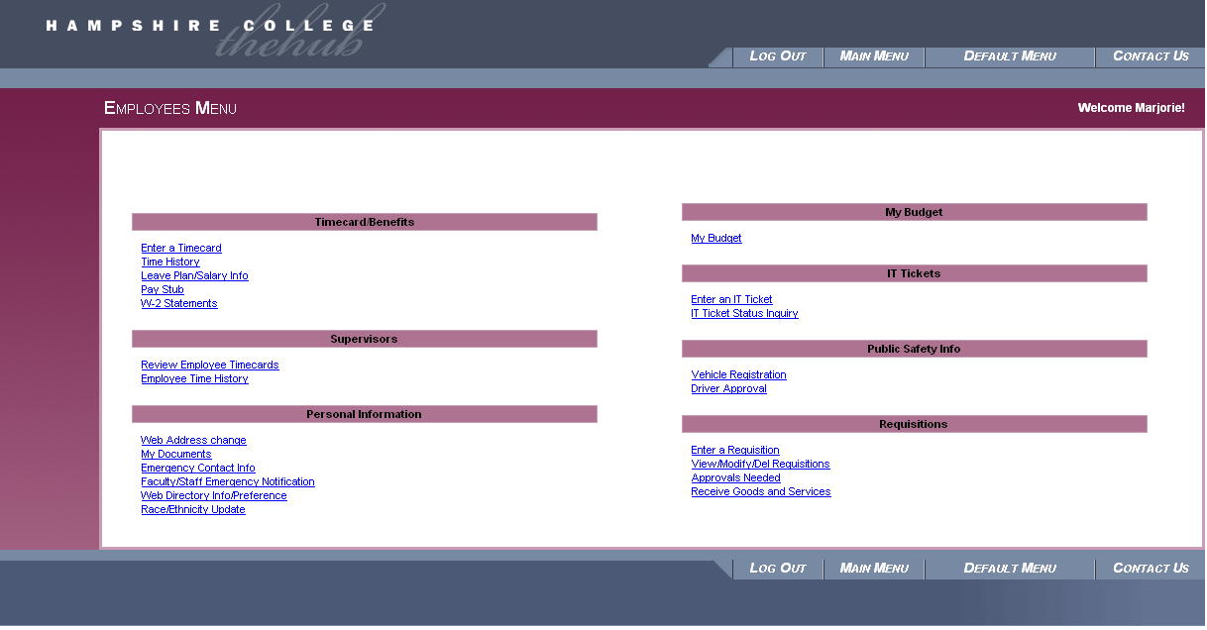
- If the information on the Approvals Needed page is correct, put a check in Approve? box and click Submit.

- At this point, you can check on the status of your requisition by clicking View/ Modify/ Delete Requisition.
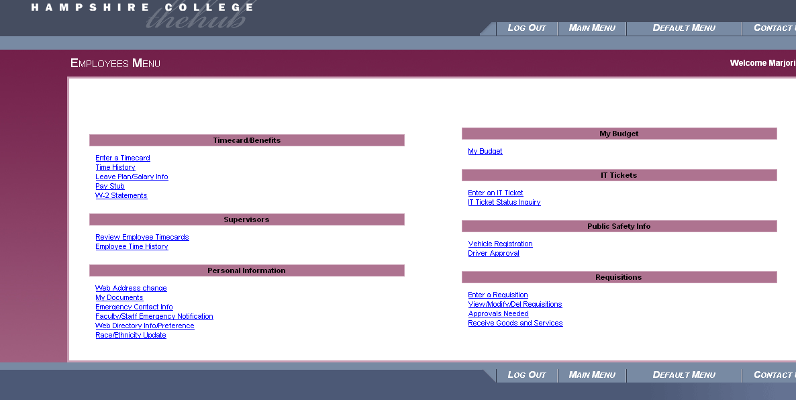
- As you can see from the screenshot below, Requisition Number 70777 has a status of Outstanding, which means a Purchase Order has not been created yet. Check back later in the day to see if the status has changed to PO Created. If the status is Not Approved, then approvals are still needed: either by you, your supervisor (if the dollar amount is over your limit), or the Business Office (if the dollar amount is over $10,000).

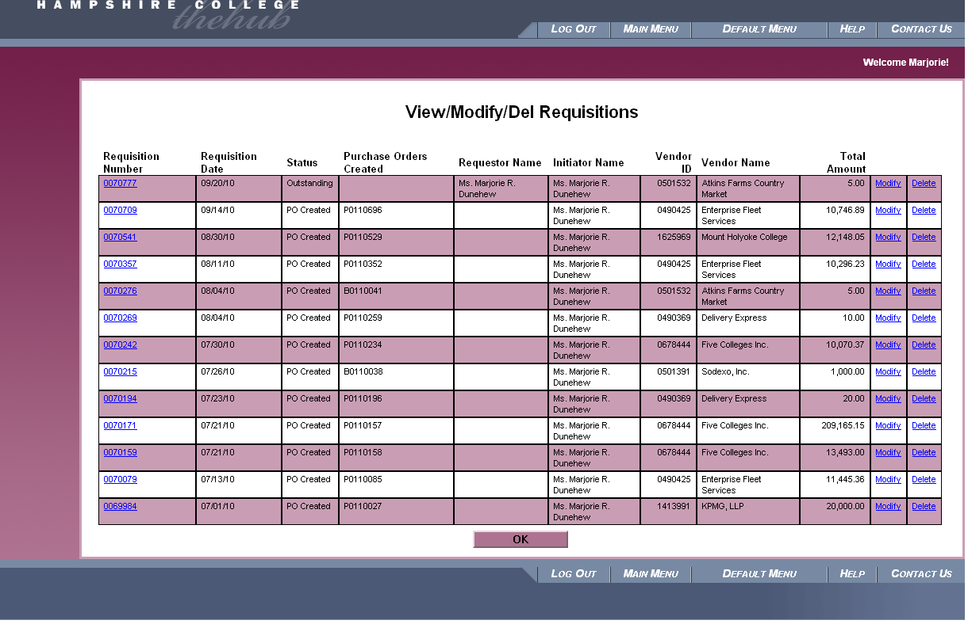

- If you would like to make a correction on an outstanding requisition, click Modify. If you would like to delete the requisition, click Delete. Note, you can only modify or delete a requisition. Once the requisition has been turned into a PO, email acctspay@hampshire.edu to delete or modify the PO.
- On the Modify a Requisition page, you can:
  - Delete the requisition by clicking on the Delete box.
  - Modify the requisition using the Modify box.
  - Inside of Modify, you can
  - Update the amount
  - Add additional line items
  - Add additional supervisors if needed in the Next Approval field
  - Select Submit when all changes/updates are complete.
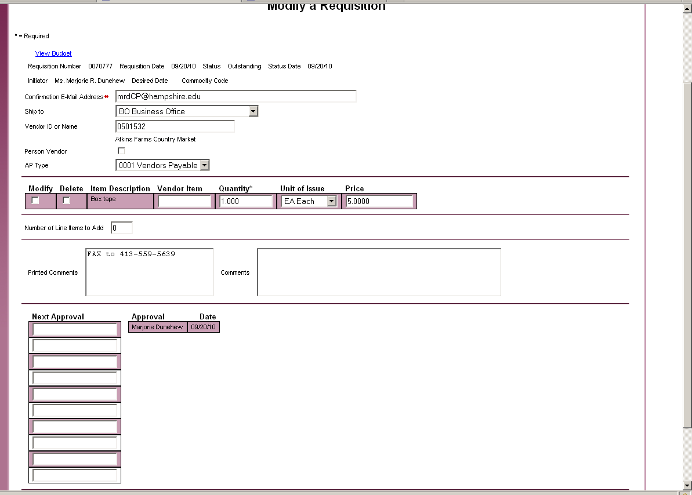
- At this point you will need to wait for the Business Office to create the Purchase Order. Once the PO number has been created, you will find it in the fourth column on the View/Modify/Delete Requisition page.
- The final step in the hub, which is easy to forget, is to accept the items (also referred to as receiving goods and services). This basically tells Accounts Payable that you did indeed get what you ordered (whether a good or a service), and that the invoice is ready to be paid. This process cannot be done until after the PO has been created, so make a note to yourself to check back in a day or two, before, sending the invoice to Accounts Payable. Click on Receive Goods and Services link from the main menu to access the Receive Goods and Services page.
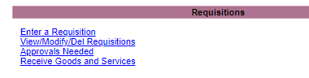
- Enter 1 in the Qty Accepted box, which should match the “1” in the Qty Ordered” box, and then click Submit. AP will not be able to send out payment until you have completed this process.
  - If you receive an MSDS from the vendor (Material Safety Data Sheet, generally for chemicals or other hazardous substances), please click the box. Please be sure to forward the MSDS to Facilities and Grounds, mail code PP.
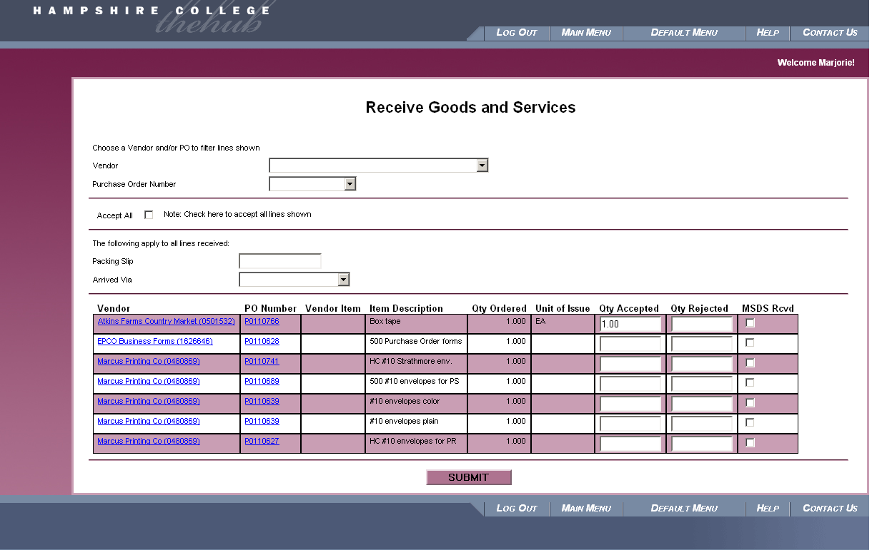
- Click OK
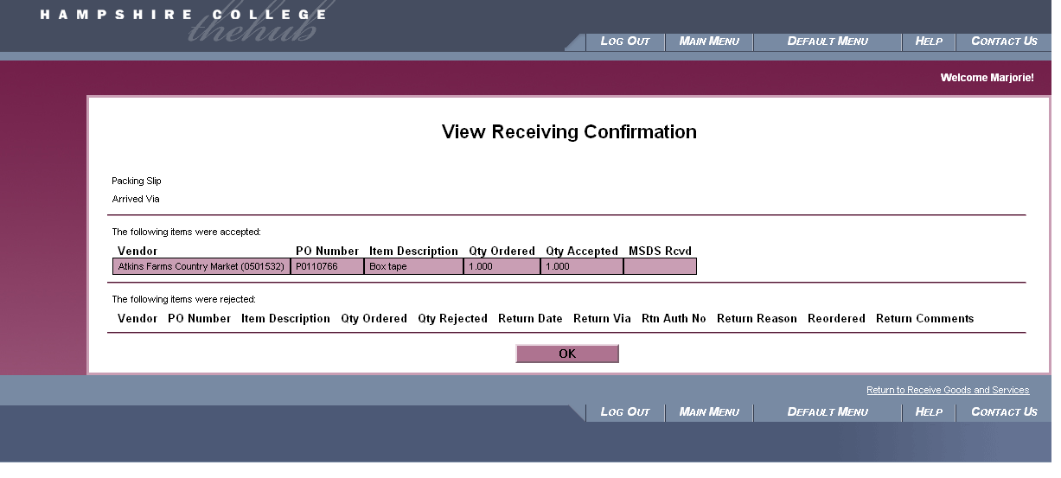
- The invoice and any accompanying forms/receipts can be sent to the Accounts Payable Department, mail code AP. They can also be emailed as attachments to acctspay@hampshire.edu. However, as with hard copies, please write the PO number on the invoice itself, not just in the subject line or in the text of the email. This prevents the invoice from becoming separated from its identifying information.
Please do not send invoices or reimbursement forms to the business office in the same envelope as pcard statements, as these items go to different recipients.
  - For invoices, write the PO number clearly at the top of the invoice.
  - For reimbursements, write the PO number in the small box found in the upper right hand corner of the Travel and Non-Travel Reimbursement forms.
    - Be sure to include all original and itemized receipts in a neatly organized manner. Small register receipts should be taped to an 8.5”x11” piece of paper. If you are missing a receipt, please fill out a Missing Receipt Affidavit, which can be found on the Business Office’s website.

Please contact Accounts Payable at acctspay@hampshire.edu or call 5491 with any questions.
A note about reimbursements: Please note that reimbursement forms essentially perform the same function as a regular invoices, except that they are slightly more complicated to put together in the first place. Like other invoices, a reimbursement still needs to receive a purchase order number. In this case, the “vendor” is the person being reimbursed. Be sure to write the PO number in the top right corner of the form, and accept the PO in the hub before sending the reimbursement form and its accompanying documentation to Accounts Payable. For more information about reimbursements, please see the Reimbursement section of the Accounts Payable website.

