Student Direct Deposit Authorization Form

Please select one of the following: New Change Cancel

Student Name: ________________________________ Student ID: _____________________________
Daytime Phone: _______________________________ Email: ___________________________________
Bank Name: __________________________________ Type: Checking Savings
*Routing Number: _____________________________ *Account Number: _______________________
*Note: Failure to supply the correct Routing Number and/or Account Number will cause a delay in the process.

I understand that:
- Direct deposit transactions will be sent to the bank.
- I should contact my financial institute to verify receipt of funds.
- I should always review my pay stub on The Hub under the Timecards option.

Please attach a voided check or direct deposit form from your bank if available

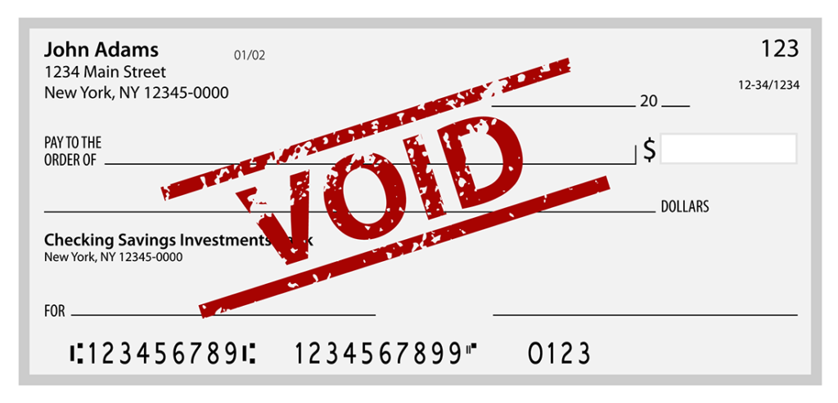

Routing Number
Account Number

I authorize Hampshire College to deposit my paycheck directly to the account above, and to correct any errors that may occur from these transactions. I authorize the financial institution indicated above to post transactions to the account. I understand that this process may take up to two pay cycles to take effect. This agreement is to remain in effect until Hampshire College receives written notice from me to cancel or change this authorization. I understand that Hampshire College is not responsible for bank errors.

Student Signature: ________________________________________ Date: ____________________________

Please return this form to the Payroll Office which is located in Blair Hall, second floor, room 217. The hours of operation are Monday through Friday 8:30AM-4:30PM (closed 12:00PM – 1:00PM)

