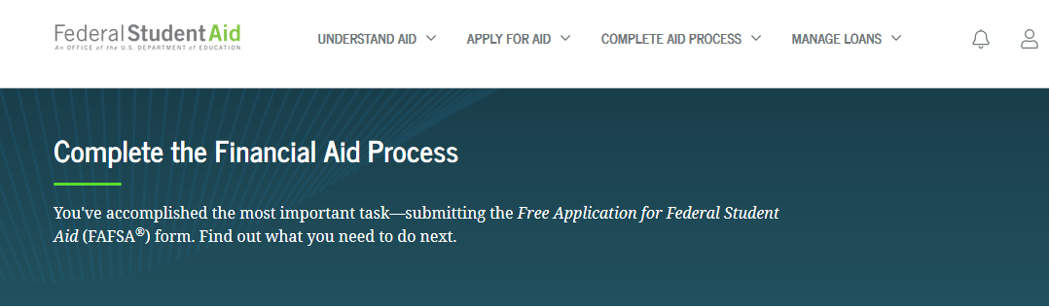
Direct Loan Entrance Counseling,
Master Promissory Note, and
Loan Acknowledgment

If you will be borrowing funds under the Federal Direct Subsidized/Unsubsidized Loan Program,
then you need to complete Entrance Counseling, a Direct Subsidized/Unsubsidized Loan
Master Promissory Note (MPN) and the Annual Student Loan Acknowledgment.

The deadline to complete these steps is July 15, 2021

Please follow the steps below to complete the required documents.
STEP 1: Log on to www.studentaid.gov using your FSA ID Username and FSA ID Password (your username and password from the FAFSA application).

STEP 2: On the main page, you will see “Complete Aid Process”, hover over that link and select “Complete Entrance Counseling” and click START, then follow these steps:
- Add School to Notify, search our state (MA) and school by name, “Hampshire College”
    - Click “Notify This School”
    - Select Student Type “I am completing entrance counseling to receive Direct Loans as an Undergraduate student,” then hit NEXT, and follow prompts

Please Note: Completing Financial Awareness Counseling does not fulfill your federal obligation for entrance counseling.

STEP 3: On the main page, you will see again see “Complete Aid Process, hover over that link and select “Complete a Master Promissory Note (MPN)” click the link and start “MPN for Undergraduates.”
- Review information and complete blank sections in order to complete your Master Promissory Note.

What you will need to complete a Master Promissory Note (MPN)
FSA ID Username and Password
Driver’s License (if applicable)
Social Security Number
Email Address
Two personal references with name, address, and phone number (References must have different addresses from one another)

STEP 4: On the main page, you will see again see “Complete Aid Process, hover over that link and select “Complete Annual Student Loan Acknowledgment,” then select Log In To Start. Follow prompts from here.

FAQs
Why do I need entrance counseling?
Entrance counseling explains your rights and responsibilities when borrowing a federal student loan. It is mandatory that you complete counseling when you borrow a Federal Direct loan.

Why is a master promissory note (MPN) needed for my Direct Student loan?
If you are borrowing a Federal Direct loan you must complete a master promissory note. This note is your contract; by signing it you are agreeing to repay your loan and abide by the terms and conditions of the loan.

Why do I need to complete the Annual Student Loan Acknowledgment for my Direct Student loan?
If this is your first time borrowing a federal student loan, then you will acknowledge that you understand your responsibility to repay your loan. If you have borrowed federal loans in the past, then you are acknowledging that you understand the amount you owe and how much more you can borrow.

Hampshire College ~ Financial Aid Office finaid@hampshire.edu 413-559-5484

