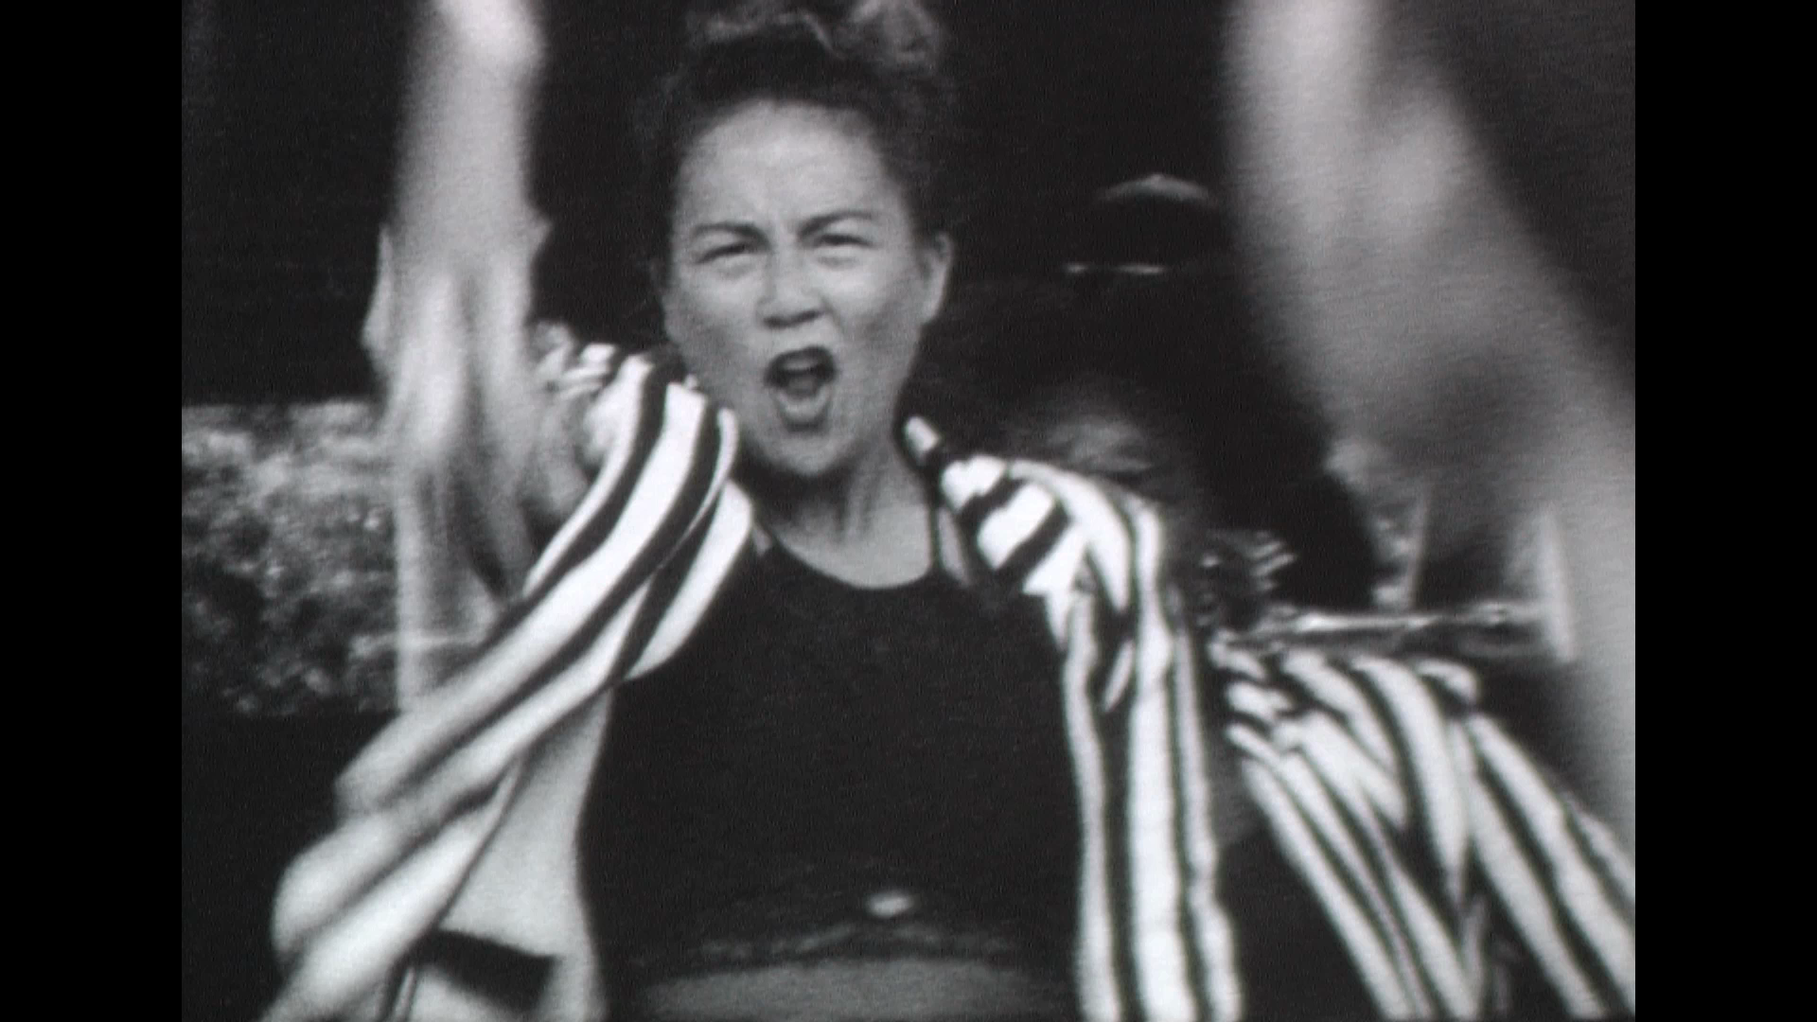
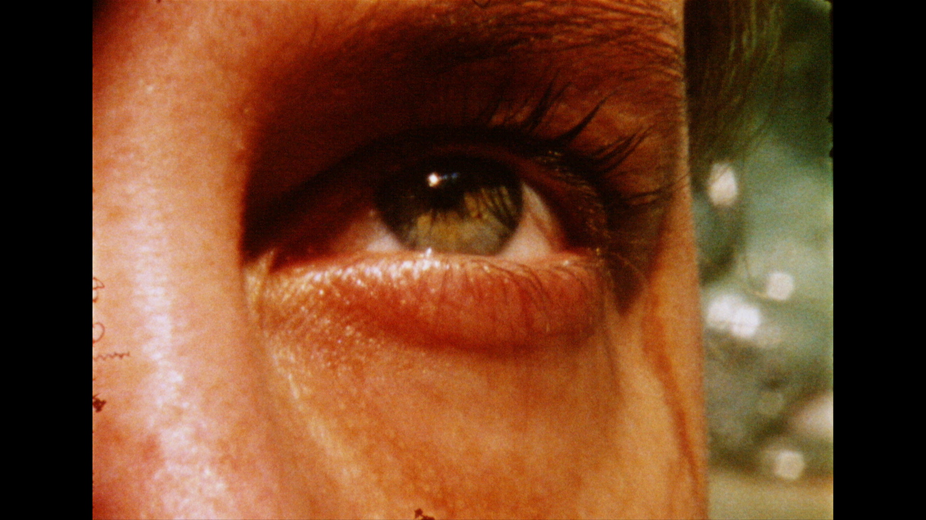
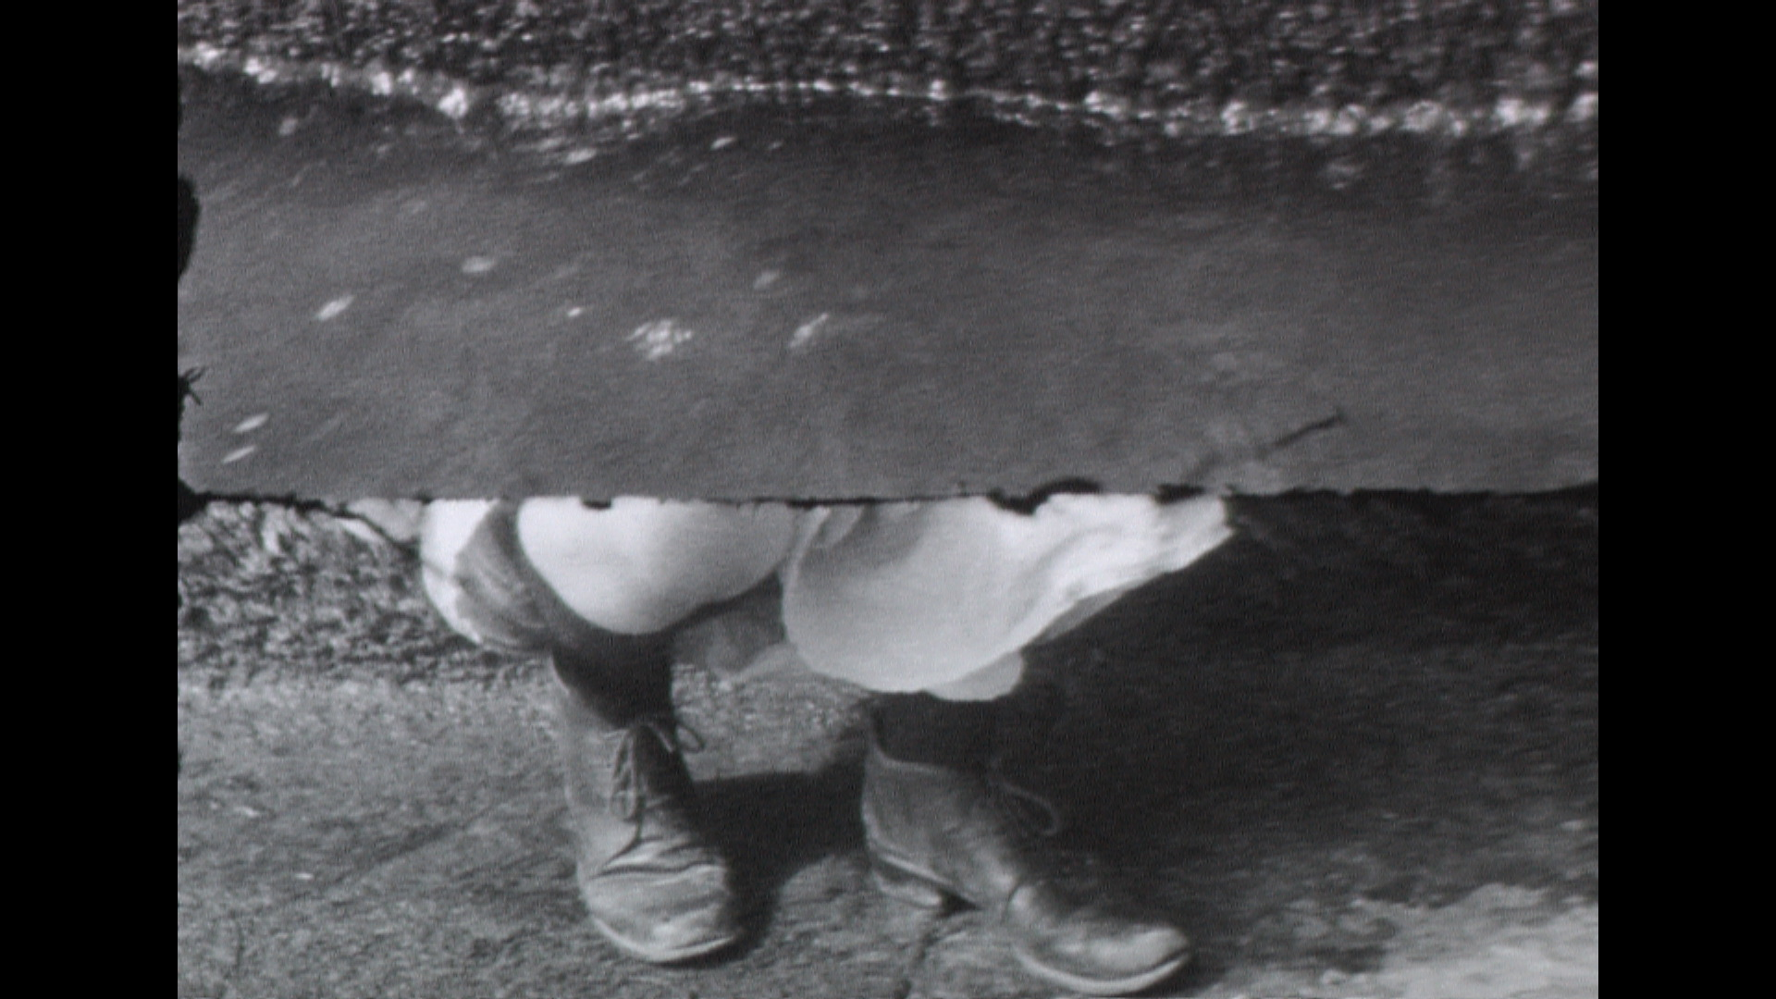
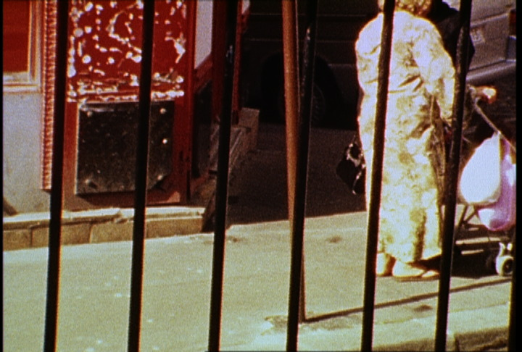

Super 8 Filmmaking in Paris: Geographies of Identity
June 1-June 18, 2019

This course combines intensive workshops in Super 8 filmmaking and film theory, including workshops on cinematography, hand-processing, animation and editing on Super 8 film. Each student will shoot, process, edit and project a short Super 8 film. All cameras, film and editing equipment are provided. The course has included studio visits with filmmakers, artists and writers including Nicole Brenez, Johanna Vaude, Mike Ladd, and Zoulikha Bouabdellah among others.

Film workshops are taught by Baba Hillman and by members of French filmmakers’ cooperatives. Students attend screenings, performances and exhibits at the Cinématheque Française, Palais de Tokyo, Centre Pompidou, L’Institut du Monde Arabe, Le Champo, Le Centquatre and other cinemas, and museums in the city. Critical work concentrates on the role of migration and diasporic communities in contemporary transnational film in Paris through a study of language, performance and visual structure within selected films. Seminars address such topics as changing cinematic representations of the architecture and urban space of the city, and the politics of film funding, production and distribution in France.

Prerequisites: Introductory film, video, photography, studio art, performance or other media practice/theory course. There are no language prerequisites. Applications are available at: https://hampshire-horizons.symplicity.com

Contact: Baba Hillman
bhillman@hampshire.edu
http://helios.hampshire.edu/~bhhCS/
https://hampshiresuper8paris.wordpress.com

